Denver Rock Boxes LLC
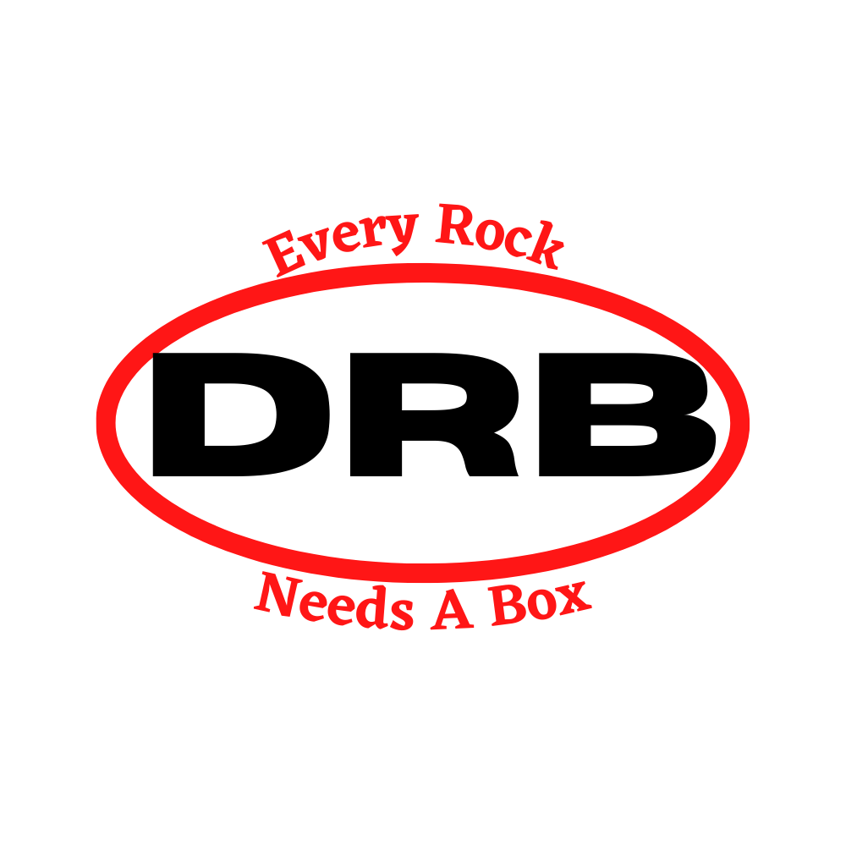
1141 W. 46th Avenue-Unit #7 Denver, CO 80211
Office (303)-433-0870 Toll-Free 1-866-710-2700
Website: https://www.denverrockboxes.com/

General Information
Discounts are based on your cumulative total within a category. For example, if you purchase 100 MFS-1 Flats and 150 MFS-2 flats, your discount is based on the 250-unit level.
Denver Rockboxes sells to both Retail and Wholesale customers. Wholesale customers must provide a valid state resale/sales tax license. -------------------------------------------------------------------
We accept: American Express, Discover, MasterCard, Visa, and PayPal for online payments and include Apple pay, Google pay and Samsung pay for all in person payments.
Thank you for your support & Business – The Denver Rock Boxes Team

Item Code | Depth of MFS Flats  (inches) | Actual box dimensions  (inches) |  | Quantity Discount Levels
 |  |  | 1 | 50 | 250 | 600 | 1,000 | Qty | Total $
Half-Flat | 1^{1/2} | Half-Flat Size  10^{1/2} X 7^{7/8} | $1.60 | $1.36 | $1.14 | $1.02 | $0.90
MFS-1 | 1^{1/2} | Standard size  10^{1/2} x 15^{1/2} (inside dimensions) | $2.52 | $2.03 | $1.85 | $1.70 | $1.53
MFS-2 | 2 |  | $3.10 | $2.36 | $2.12 | $1.94 | $1.79
MFS-3 | 3 |  | $3.63 | $2.78 | $2.46 | $2.28 | $2.12
MFS-4 | 4 |  | $4.48 | $3.44 | $3.07 | $2.82 | $2.60
MFS-6 | 6 |  | $5.49 | $4.09 | $3.79 | $3.48 | $3.18
Customer Flat | 2 | Fold Up Flat | $0.79 | $0.73 | $0.68 | $0.68 | $0.68
Category 1- Flats (Mineral flats for carrying and displaying Gems and Minerals)

Important note: MFS Flats are shipped unassembled/flat.

Item  Code | Number of boxes per MFS Flat | Depth of boxes  (inches) | Actual box dimensions  (inches) | Price per box based on quantity
 |  |  |  | Quantity Discount Levels
 |  |  |  | 1 | 50 | 250 | 600 | 1,000 | Qty | Total $
PFB-4 | 4 | 2 | 7^{1/2} x 4^{15/16} | $4.76 | $3.61 | $3.19 | $2.71 | $2.55
PFB-4D | 4 | 3^{7/8} | 7^{1/2} x 4^{15/16} | $5.57 | $4.23 | $3.74 | $3.29 | $3.11
PFB-6 | 6 | 2 | 4^{15/16} x 4^{15/16} | $3.98 | $2.96 | $2.49 | $2.30 | $2.10
PFB-6D | 6 | 3^{7/8} | 4^{15/16} x 4^{15/16} | $4.52 | $3.52 | $3.03 | $2.81 | $2.53
PFB-8 | 8 | 2 | 4^{7/8} x 3^{9/16} | $2.35 | $1.85 | $1.67 | $1.54 | $1.38
PFB-8D | 8 | 2^{7/8} | 4^{7/8} x 3^{9/16} | $2.95 | $2.51 | $2.24 | $2.06 | $1.85
PFB-12 | 12 | 2 | 3^{9/16} x 3^{1/8} | $1.56 | $1.24 | $1.12 | $1.02 | $0.94
PFB-12D | 12 | 2^{7/8} | 3^{9/16} x 3^{1/8} | $2.00 | $1.69 | $1.56 | $1.43 | $1.30
PFB-18 | 18 | 1^{1/2} | 3^{1/8} x 2^{5/16} | $1.51 | $1.19 | $1.07 | $0.98 | $0.89
PFB-24 | 24 | 1^{1/2} | 2^{5/16} x 2^{5/16} | $1.44 | $1.08 | $0.99 | $0.90 | $0.86
PFB-32 | 32 | 1^{1/16} | 2^{5/16} x 1^{11/16} | $1.38 | $1.04 | $0.95 | $0.89 | $0.85
Category 2- Cotton Filled “Perfect Fit” (White, Pebble-grain leatherette)

Category 3- Fold-Up Boxes (Economical Fold-Up paperboard boxes)

Item  Code | Number of boxes per  MFS Flat | Depth of boxes  (inches) | Actual box dimensions  (inches) | Price per 100 boxes based on quantity
 |  |  |  | Quantity Discount Levels
 |  |  |  | 100 | 1,000 | 6,000 | 10,000 | Qty | Total $
FB-4 | 4 | 1 ½ | 7 ¾ x 5 1/3 | $36.91 | $33.33 | $32.07 | $30.81
FB-6 | 6 | 1^{1/2} | 5^{1/8} x 5^{1/8} | $32.66 | $28.99 | $27.77 | $26.57
FB-8 | 8 | 1^{3/8} | 5^{1/8} x 3^{3/4} | $28.34 | $25.81 | $24.96 | $24.10
FB-12 | 12 | 1^{3/8} | 3^{3/4} x 3^{1/4} | $22.70 | $18.45 | $17.60 | $16.74
FB-18 | 18 | 1^{1/8} | 3^{1/4} x 2^{1/2} | $16.82 | $14.53 | $13.96 | $13.38
FB-20L | 20 | 1 | 5^{1/8} x 1^{1/2} | $16.25 | $13.11 | $12.60 | $12.08
FB-24 | 24 | 1 | 2^{1/2} x 2^{3/8} | $12.65 | $11.08 | $10.64 | $10.19
FB-25 | 25 | 1 | 3 x 2 | $12.65 | $11.08 | $10.64 | $10.19
FB-35 | 35 | 1 | 2 x 2 | $11.42 | $9.79 | $9.18 | $8.57
FB-42L | 42 | ¾ | 3^{3/4} x 1 | $11.35 | $9.75 | $9.13 | $8.53
FB-54 | 54 | ¾ | 1^{1/2} x 1^{1/2} | $8.57 | $7.70 | $7.30 | $6.93

Category 4- Acrylic Bases

Item  Code | Description of Item | Depth of bases  (inches) | Actual box dimensions  (inches) | Price per box based on quantity  Quantity Discount Levels
 |  |  |  | 1 | 100 | 250 | Qty | Total $
Acrylic Base 11/4 | Base | 1/4 | 11/4 x 11/4 | $0.58 | $0.48 | $0.39
Acrylic Base 11/4 X 11/2 | Base | 1/4 | 11/4 X 11/2 | $0.58 | $0.48 | $0.39
Acrylic Base 11/2 | Base | 1/4 | 11/2 x 11/2 | $0.64 | $0.53 | $0.55
Acrylic Base 2 x 2 | Base | 1/4 | 2 x 2 | $2.67 | 24= $2.40 | 48= $2.14
Acrylic Base 2 x 3 | Base | 1/4 | 2 x 3 | $3.74 | 24= $3.21 | 48= $2.67
Slotted Acrylic Base | Label Holder | 1/4 | 1 ¼ x 1 | $0.58 | $0.48 | $0.39
Acrylic Base 1^{3/16} x 1^{3/16} Black | Base | 1/4 | 1^{3/16} x 1^{3/16} | $0.58 | $0.48 | $0.39
Acrylic Base 1^{3/16} x 1^{3/16} Clear | Base | 1/4 | 1^{3/16} x 1^{3/16} | $0.58 | $0.48 | $0.39

Category 5- Perky Boxes & Acrylics for Perky Boxes

Item  Code | Number of boxes per  MFS Flat | Depth of boxes  (inches) | Actual box dimensions  (inches) | Price per box based on quantity
 |  |  |  | Quantity Discount Levels
 |  |  |  | 1 | 70 | 350 | Case  (700) | Qty | Total $
Perky Box | 70 | 1^{1/4} | 1^{1/4} x 1^{1/4} | $0.80 | $0.69 | $0.64 | $0.58
Acrylic Base 1^{3/16} Clear |  | 1/4 | 1^{3/16} x 1^{3/16} | $0.58 | $0.48 | $0.39 | N/A
Acrylic Base 1^{3/16} Black |  | 1/4 | 1^{3/16} x 1^{3/16} | $0.58 | $0.48 | $0.39 | N/A

Category 6- Acrylic Stands (3 & 4 Prongs)

Item  Code | Description of Item | Actual Base dimensions  (inches)
 |  |  | 1-23 | 24-47 | 48+
Acrylic 1 ½ - 3 Prong | Pronged Base | 1 ½ x 1 ½ | $2.52 | $2.25 | $1.99
Acrylic 1 ½ - 4 Prong | Pronged Base | 1 ½ x 1 ½ | $2.71 | $2.45 | $2.18
Acrylic 2 – 3 Prong | Pronged Base | 2 X 2 - 2 x 2 ½ | $2.81 | $2.54 | $2.27
Acrylic 2 x 2 1/2 -3 Prong | Pronged Base |  | $2.81 | $2.54 | $2.27
Acrylic 2 – 4 Prong | Pronged Base | 2 x 2 | $3.03 | $2.77 | $2.50
Acrylic 3 - 3 Prong | Pronged Base | 3 x 3 | $3.35 | $3.09 | $2.82
Acrylic 3 – 4 Prong | Pronged Base | 3 x 3 | $3.45 | $3.18 | $2.92
Acrylic 4 – 3 Prong | Pronged Base | 4 x 4 | $3.74 | $3.47 | $3.21
Acrylic 4 – 4 Prong | Pronged Base | 4 x 4 | $4.17 | $3.90 | $3.63

Item | Unit Price | Qty Discount | Qty | Total $
Salco P694 - jam-resistant, heavy-duty stapler | $56.17 | No Disc.
Bostitch - heavy-duty stapler | $45.47 | No Disc.
Box of 5,000 galvanized staples (310/9) | $19.26 | No Disc.
Plastic bags - bag size 21” x 38” (roll weighs 24 lbs) | 1= $77.04 | 5+ $74
Vinyl Plastic Sleeves 3 ¾“x 2 ¾“ self-adhesive | 1= $0.26 | 100+ $0.21
Jewelers Loupe | 1= $5.35 | No Disc.
Geo-Tack 80 Gram Pack (Reusable adhesive) | 1= $7.00 | No Disc.
Category 7- Staplers & Other supplies

